

Weather APP - API Project

Developed by Atit Patel



June 9, 2021

Atit patel

Lovelearninginfinity50@gmail.com

**Manual for Weather Project**

This app would allows customer to search the current weather while entering the city names. Below are the images of my app!

This app havent been uploaded to the server so, to use it please use the app, please follow the below steps:

Step1: Download alll the files and open it into atom.

Step 2: Open hyper terminal/Git initialize the node.js and install express.js, body-parser and nodemon

Step 3: After downlaoding all the required modules as mention above enter commond **nodemon app.js** to your git/hyperterminal.

Step 4: open a new tab and enter **localhost: 3000**

Step 5: Your app will open up. As the screenshot displayed below.



[Figure1: UI]

**Example 1:**

**Input City: Miami**



[Example 1: Miami]

**Example 1:**

**Output: 30.81 degree Celsius**

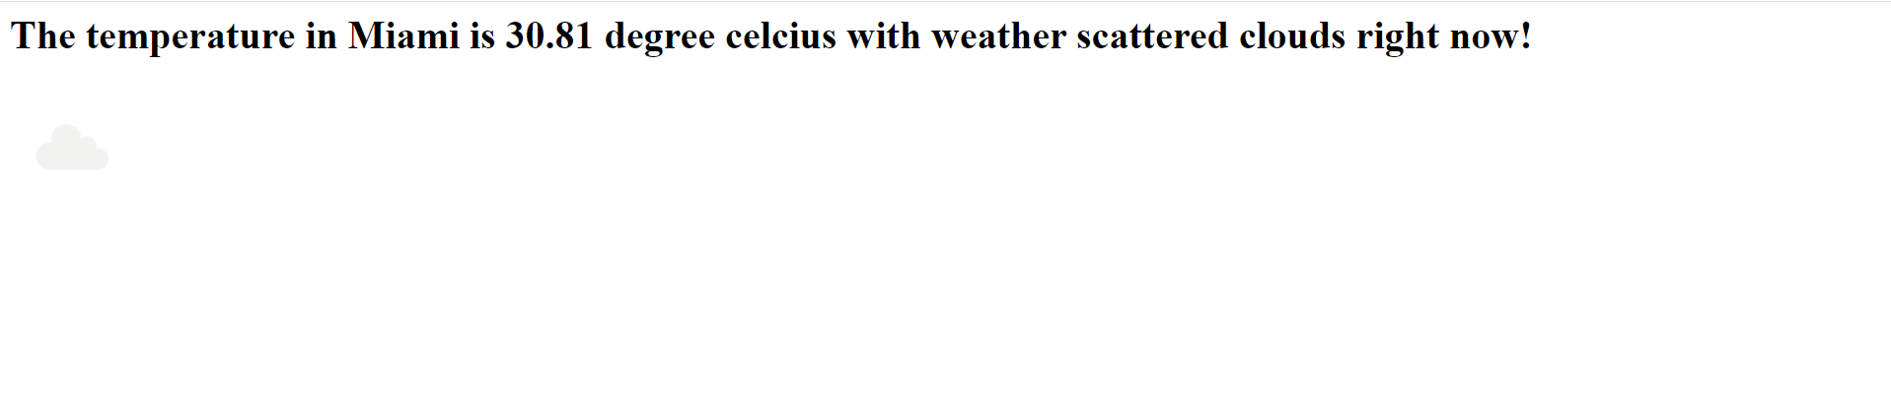

**Example 2:**

**Input City: Waterloo**



[[Example 2: Waterloo]

**Example 2:**

**Output: 16.78 degree Celsius**

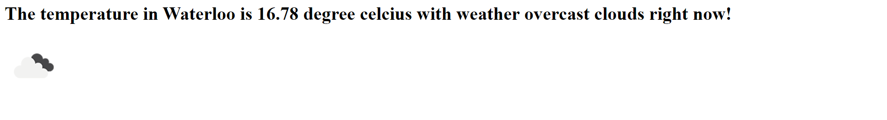

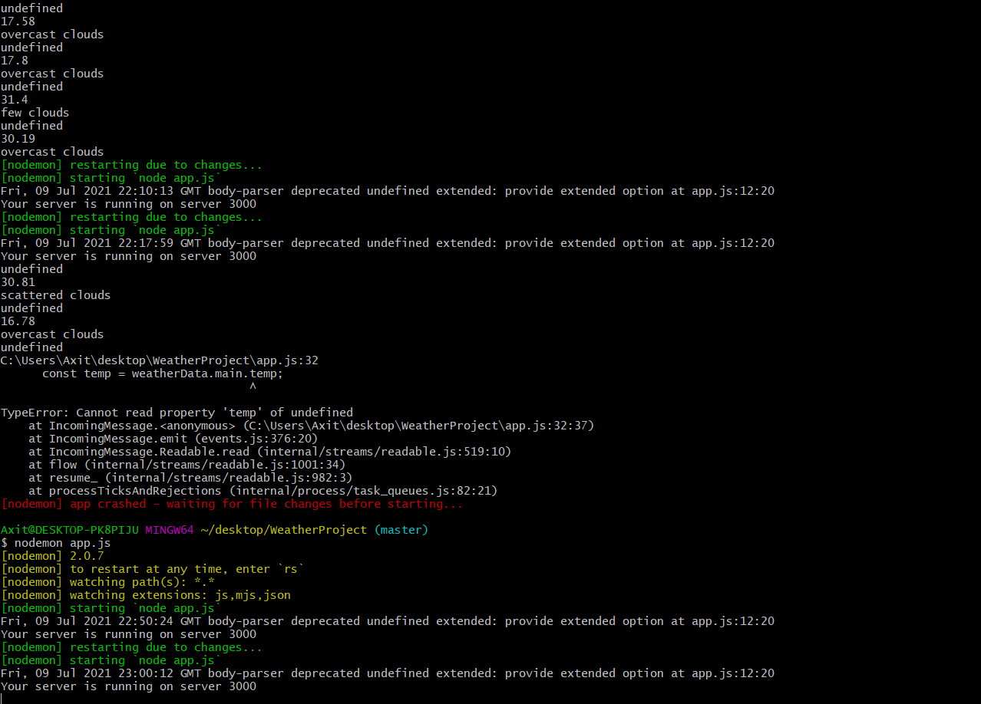

To complete this above project I have used [Open Weather API](https://openweathermap.org/weather-conditions) services which is free for 60 clicks in 1 hour.

**Technology used:**

HTML5, CSS3, JAVASCRIPT, JQUERY, NODE.JS, EXPRESS.JS, API, & GIT